CROWBOROUGH ARTS OPEN STUDIOS 1st & 2nd SEPTEMBER 2018 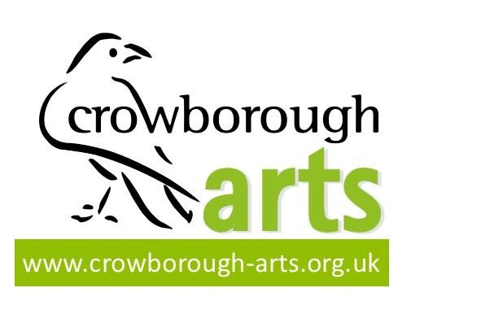
PLEASE FILL IN ON THE COMPUTER. The boxes expand as you type in the info – if needed.
First time participants, please fill in your location as per the instructions on the blank map on the website

Email form and jpg photos to: bridgetmarchi@hotmail.com 21st Dec. 2017

YOUR CONTACT DETAILS
- Name
- Home address

- Postcode
- Email
- Telephone number
- Your website/Facebook page info.

- Studio address, if different from home address. If you are not using your Studio – leave blank
YOUR VENUE INFORMATION
- Describe access, ie in garden, through front
door etc

- Any problems regarding location or access including parking restrictions, steps etc especially with regard to wheelchair users or people with mobility issues?
SHARING YOUR STUDIO
- Are you willing to share your studio with other artists?
- If so, what type of space could you provide– wall/hanging space, floor space, tablespace, outside, gazebo or tent (please specify)
VENUE NEEDED
- Have you already arranged a venue to share?
If so – where and with whom?

If not, state the type of venue you need:

- Wall/hanging space
- Floor space
- Tablespace
- Outside etc. (please specify)
- Do you have a gazebo or tent?
- Do you have a table you could bring?
YOUR WORK
- Description for brochure entry, (2- 4 words only): medium/craft/subject matter
- Artists statement for website (150 word max)

(box will expand to take full entry)

- Please send 3 images at 300 dpi (high resolution) for use in brochure & website  First photo should be landscape for the brochure, all 3 will go on the website | Included YES/NO
- Please tick to confirm that you have read and will comply with the Terms and Conditions for Participants
PAYMENT | Please indicate £25 or £40
- Crowborough Arts member - £25
- Non Members - £40
(this gives a year’s membership)

PAYMENT METHOD | Please indicate amount and method
- BACS payment. Account name: Crowborough Arts,
Sort Code 20-88-13 Account number: 93657043 with the reference OS + Surname

Or post a cheque
- To Crowborough Arts, c/o Green Cottage, Green Lane, Crowborough, TN6 2DF
Closing date for entries 20th APRIL 2018  NO ENTRIES WILL BE CONSIDERED AFTER THIS DATE. | ALL CONDITIONS OF ENTRY NEED TO BE FULFILLED BEFORE THE CLOSING DATE

Application forms: Bridget Marchi bridgetmarchi@hotmail.com Tel. no. 01892 668846
General enquiries: Jane Smith: janemanchoo@btinternet.com Tel.no. 01892 654301

