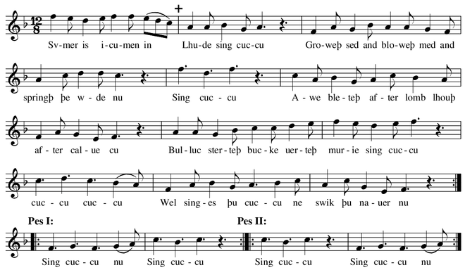

Middle English  Sumer is icumen in  Lhude sing cuccu  Groweþ sed  and bloweþ med  and springþ þe wde nu  Sing cuccu  Awe bleteþ after lomb  lhouþ after calue cu  Bulluc sterteþ  bucke uerteþ  murie sing cuccu  Cuccu cuccu  Wel singes þu cuccu  ne swik þu nauer nu  Sing cuccu nu • Sing cuccu.  Sing cuccu • Sing cuccu nu^{[8]} | Modern English  Summer^{[a]} has arrived,  Loudly sing, cuckoo!  The seed is growing  And the meadow is blooming,  And the wood is coming into leaf now,  Sing, cuckoo!  The ewe is bleating after her lamb,  The cow is lowing after her calf;  The bullock is prancing,  The billy-goat farting, [or "The stag cavorting"^{[10]}]  Sing merrily, cuckoo!  Cuckoo, cuckoo,  You sing well, cuckoo,  Never stop now.  Sing, cuckoo, now; sing, cuckoo;  Sing, cuckoo; sing, cuckoo, now!^{[11]}

